**MINISTRY OF EDUCATION AND TRAINING**

**HCMC UNIVERSITY OF TECHNOLOGY AND EDUCATION**

**FACULTY FOR HIGH-QUALITY TRAINING**

**____________________________________**

 

Final Report

**IT PROJECT**

Topic

**Food Store Application**

Lecturer: Hoang Van Dung

|  |  |
| --- | --- |
| Student name | ID |
| Nguyễn Trung Nguyên | 20110388 |

*HCMC 2022 - 2023*

**THANK YOU**

In order to successfully complete this topic and this report, we would like to extend our sincere thanks to our lecturer, Mr.Nguyen Thanh Son, who directly supported us throughout the process of making the topic. Thank you for giving us advices from his practical experience to guide us in the right direction with the requirements of the selected topic, always answer questions and give suggestions and corrections in time to help us overcome my shortcomings and complete the project on schedule.

We also would like to express our sincere thanks to the teachers in the High Quality Education Department in general and the Information Technology faculty in particular for their dedicated knowledge to help us gain a foundation to make this project. This topic has created conditions for us to learn and perform well on the topic. Along with that, we would like to thank our classmates for providing useful informations and knowledges to help us improve our report.

The topic and report are made by ourselves in a short time, with limited knowledge and many other limitations in terms of technicals and experiences in managing university. Therefore, in the process of creating this topic with shortcomings is inevitable, we look forward to receiving valuable comments from the teachers to make our knowledges more complete and we can do even better next time. We sincerely thank you.

At the end, we would like to wish all teachers staffs always having abundant health and more success in the career of teaching students. Once again we sincerely thank you.

Table of Contents

Introduction 4

I. PROJECT SPECIFICATION 5

II. DATABASE DESIGN 6

2.1. ERD model 6

2.2.Logical level database design: Converting ERD to a relational model 6

2.3 Diagram of the database: 7

III. FUNCTIONS 7

3.1. Forms: 7

3.1.1. Login form: 7

3.1.2. Main form: 8

3.1.3. Admin from: 8

3.1.4. Employee revenue form: 12

3.2. Code: 12

3.2.1. Account: 12

3.2.2 Category 14

3.2.3 Food: 16

3.2.4 Table: 18

3.2.5 BillInfor: 20

3.2.6. ChiPhi: 21

3.2.7. DataProvider: 22

3.2.8. Menu: 24

V. CONCLUSION 27

# Introduction

Software and applications are increasingly attracting the attention of numerous countries as the globe enters the Fourth Industrial Revolution. Online software and applications are no longer a novel industry in our nation or a weird notion in society. Online software services are steadily growing, developing aggressively, and playing an increasingly significant role in the sphere of technology development in Vietnam, following the global trend of technological growth. In 2021, the COVID-19 pandemic is likely to have wreaked havoc on the economy and human life in a variety of ways. As a result, the deployment of online software service tools for learning has played an important role for all people, particularly pupils, students, teachers, and lecturers, in ensuring conditions for learning and cultivating knowledge while the entire country manages the case and education stage of the people.

Most nations are currently attempting to get all of their citizens vaccinated so that management and learning may continue uninterrupted, and there is a management tool to help with this massive task. Student management software is an excellent instrument for providing administrative and pedagogical assistance. We had to design and customize the software to match the demands of the users in order to create this application.

As a result, our team opted to demonstrate Food store management software using the C# programming language match with Microsoft SQL sever in this project.

I. PROJECT SPECIFICATION

Project title: Building a Food store management system to calculate money by table, manage bills

To meet the requirements on the system need to be able to store. Composition data: Each drink has a code to manage, the name of the drink and the remaining quantity. Each type of food must have a code to manage, the name of the food and the remaining quantity. Each employee has an employee code to manage, an employee's name, number of working days, basic salary and allowance, and position. Each table must have a table code to manage, the status of the table is empty or occupied, and an employee code to know which staff is serving that table (identified by MaNV). Each invoice must have an invoice code for management, entry time, exit time, table code (determined by maBan), waiter code for that table (maNV), food and beverage code, discount (if applicable). yes ). Each menu must have the food code, the name of the food, the amount of food left, the drink code, the name of the drink, and the amount of the remaining drinks.

In order to achieve the requirements on the system, the following functions are required: Add, delete, edit for each type of corresponding stored data such as adding, deleting, editing new dishes and drinks to the menu. Search for food and drinks in the menu. Add, delete, edit information for an employee. The function of ordering food, ordering food, marking the table as already occupied by someone to pay, changes the table status to an empty state. Print invoices for customers and save invoices on the system.

II. DATABASE DESIGN

## **2.1. ERD model**

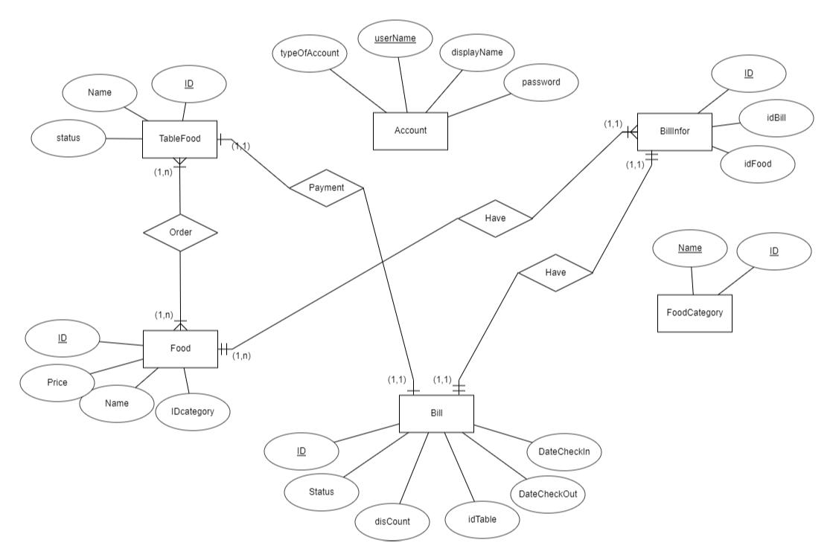

## **2.2. Logical level database design: Converting ERD to a relational model**

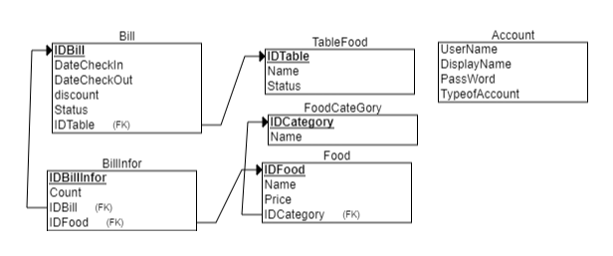

**2.3 Diagram of the database:**

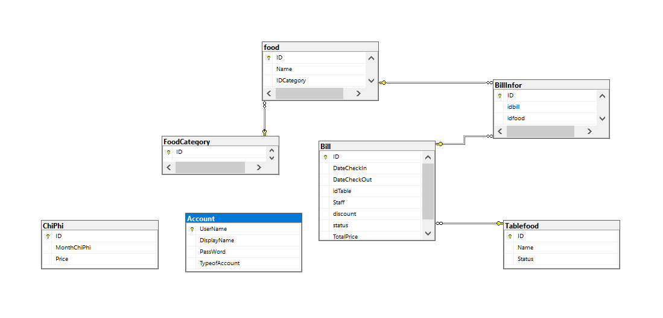

TableFood(IDTable , Name, Status)

FoodCateGory(IDCategory, Name)

Food(IDFood, Price, Name, IDCategory)

Bill(IDBill, DateCheckIn, DateCheckOut, Staff, Discount, Status, IDTable)

BillInFor(IDBillInFor, Count, IDBill, IDFood)

Account(UserName, DisplayName, PassWord, TypeofAccount)

ChiPhi(ID, MonthChiPhi, Price)

III. FUNCTIONS

**3.1. Forms:**

**3.1.1. Login form:**

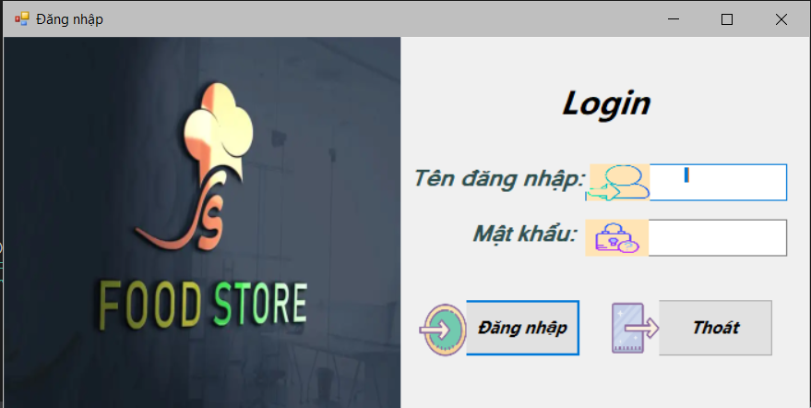

### 3.1.2. Main form:



### 3.1.3. Admin from:

Statistics of the restaurant's revenue by the date entered by the user. Full display of restaurant information and revenue.



Manage restaurant input costs, Add and delete costs and calculate the total profit of the restaurant through the date entered by the user.



Manage food, add, update and delete food, feed price.



Manage category of food, add, update and delete category of food.



Mange account, add, update and delete account.



### 3.1.4. Employee revenue form:

Statistics of sales orders and total revenue of employees entered by the user. Convenient to calculate salary for employees.

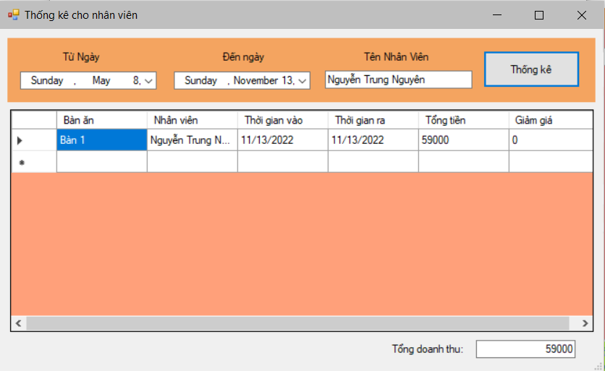

## 3.2. Code:

### 3.2.1. Account:

With 3 layer model we have DTO to define the properties of object, DAO to define method of object.

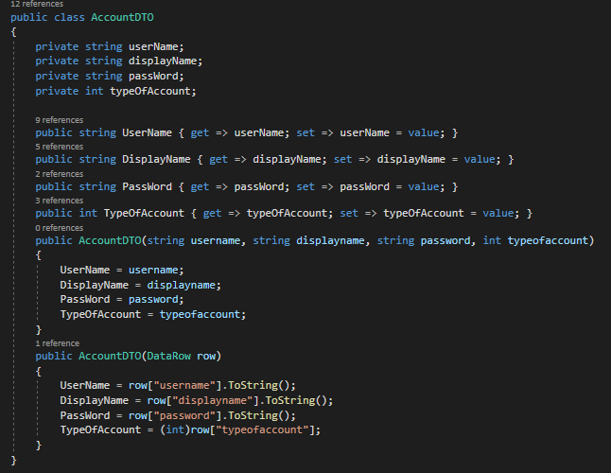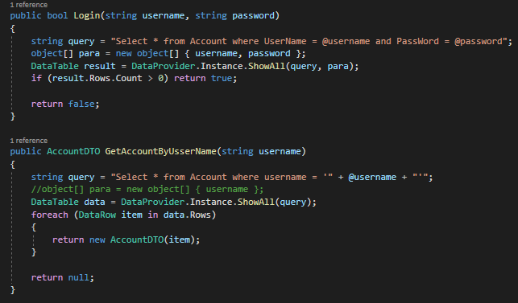

Function login is select infor with parameter username and password that the user enters. If there is more than one data line, let login. But there is no data line so that login is not allowed. Funtion account is select infor of account with username. It helps user get all information of staff.

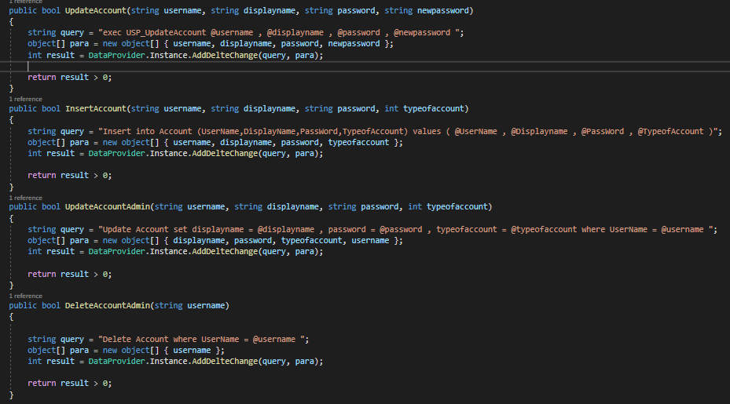

All function are insert, update, delete information of account.

### 3.2.2 Category:

Funtion GetListCategory: we difine the List<CategoryDTO> to restore the data of category into list categories. And display to user. Funtion GetListCategoryByID: This function have user get all information of category when iput the parameter ID

Norther funtion is insert, update, delete category of food.

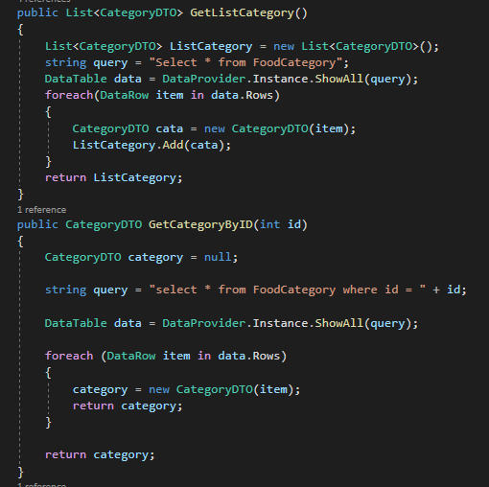

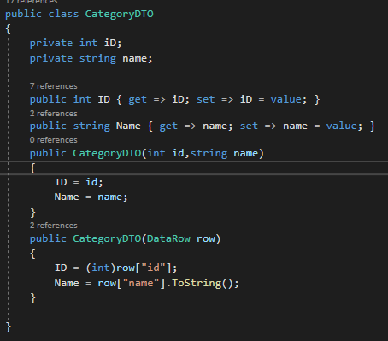

### 3.2.3 Food:

Function GetAllFoodByCategory: User enter IDCategory and this function return a datatable of Food.

Insert, Update, Delete food function.

Function DeleteFoodByIDCategory: If user want to delete a category, the program must delete all food in this category first and then delete this food category.

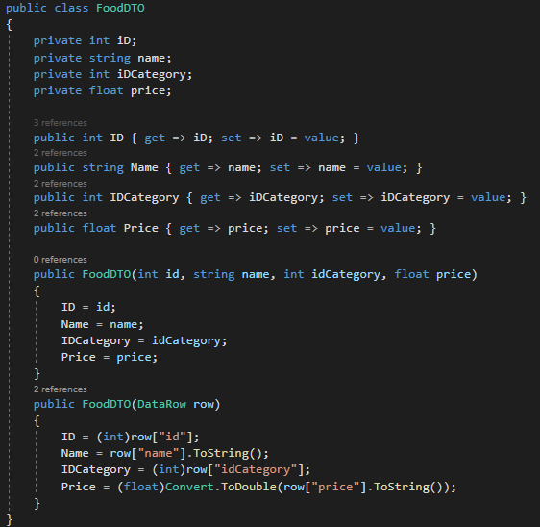

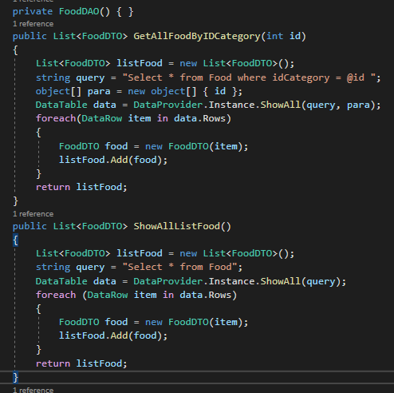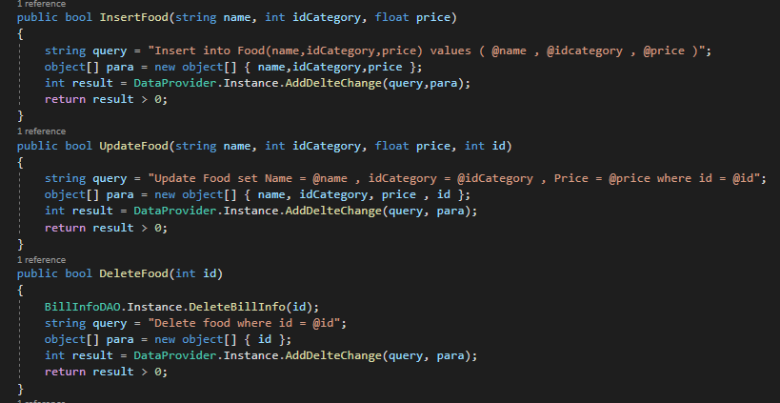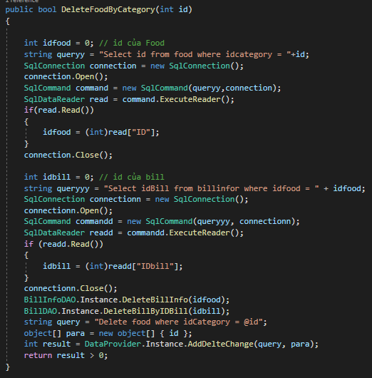

### 3.2.4 Table:

Function LoadListTable: To show all tables to the panel in C# window.

Add table, Delete table

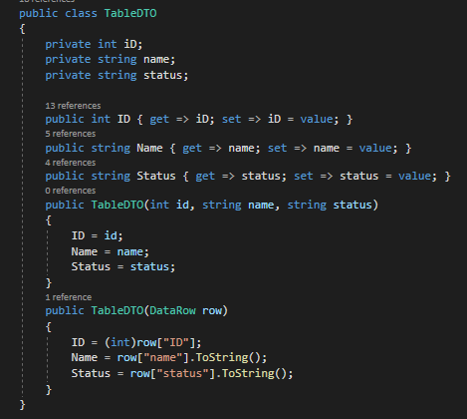

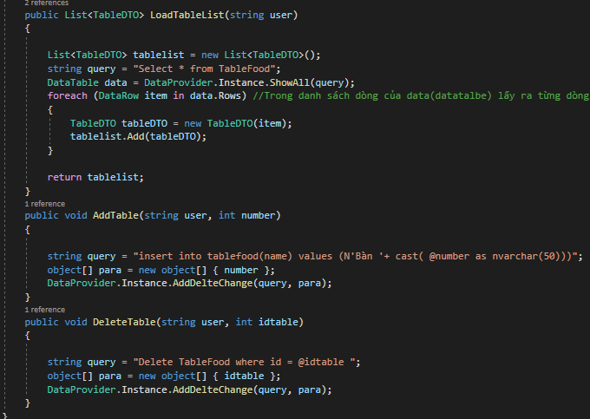

### 3.2.5 BillInfor:

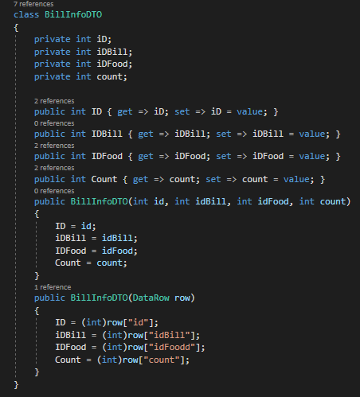

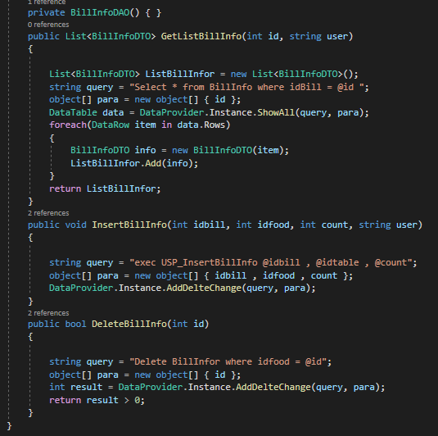

Function GetListBillInfor to select all data in table BillInfor.

Funtion InsertBillInfor to insert data to table.

Funtion DeleteBillInfo to delete data with id that user entered.

### 3.2.6. ChiPhi:

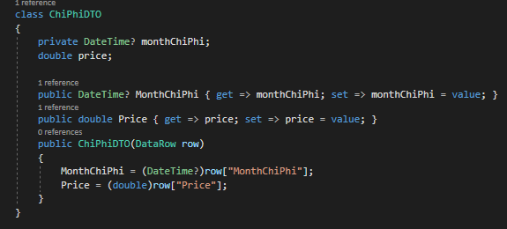

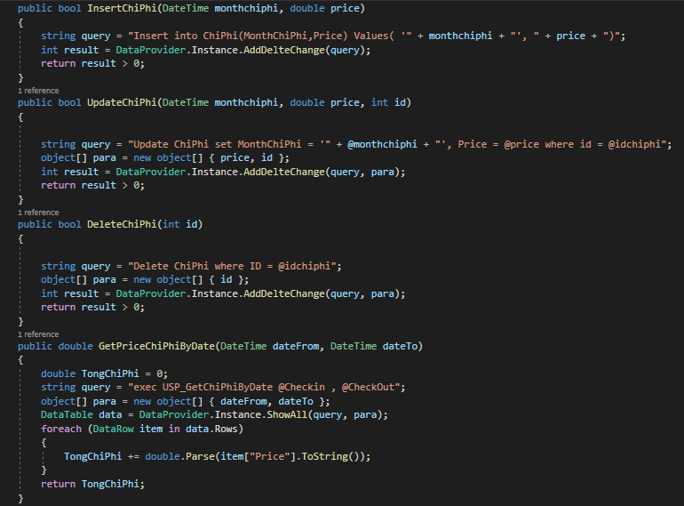

Function GetListBillInfor to select all data in table BillInfor.

Funtion InsertChiPhi to insert data to table.

Funtion DeleteChiPhi to delete data with id that user entered.

Function GetPriceChiPhiByDate to get the price between the date from and date to that user entered.

### 3.2.7. DataProvider:

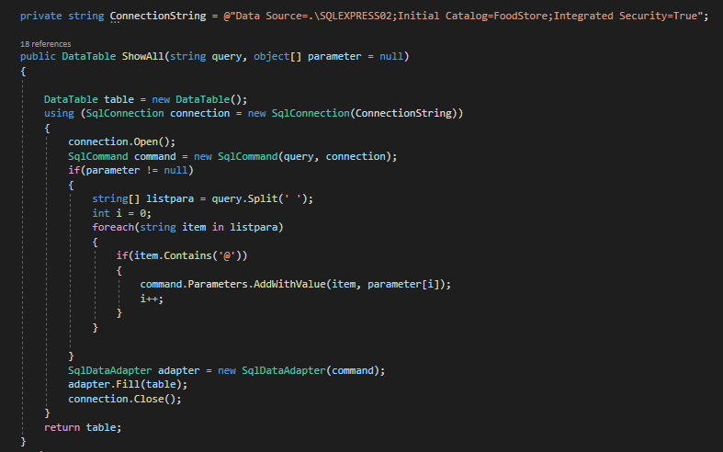

This function use to select data from database. It uses in many functions like: GetList…(), GetAll…()

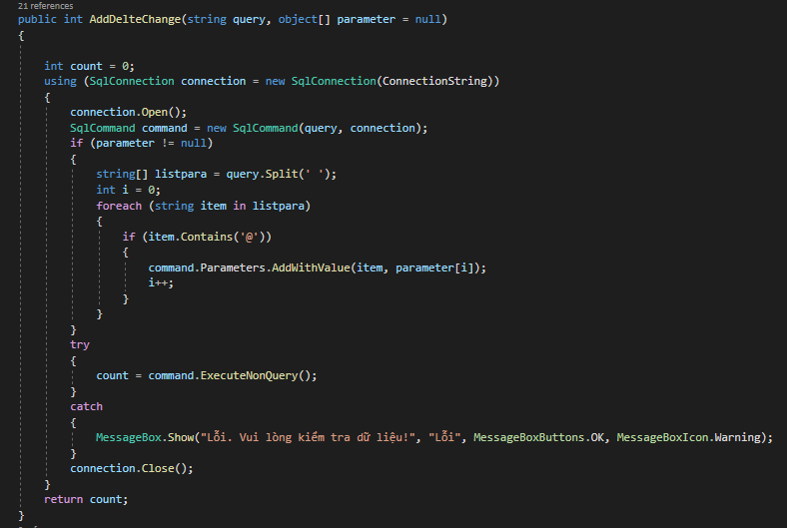

This function use to add, update and delete data from database.

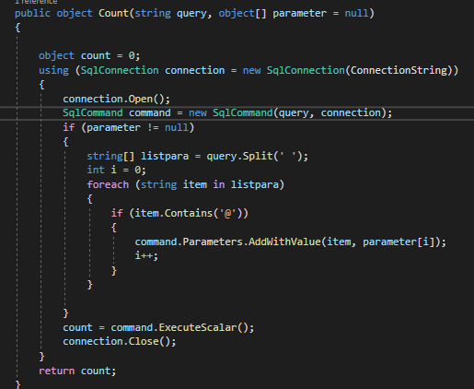

This function is used to count the number of rows of data when we select and return the amount of data.

### 3.2.8. Menu:

Class Menu has functions GetAllFoodByIDCategory(id), ShowAllListFood(), InsertFood(name,idCategory,price), UpdateFood(name, idCategory, Price, id), DeleteFood(id), DeleteFoodByCategory(id).

GetAllFoodByIDCategory(id): Get food belong the category that the user entered

ShowAllListFood(): Get all food in the table Food in database.

InsertFood(): Insert new food with the parameter that the user entered. The ID column increase automatically after inserting.

UpdateFood():Update food with the parameter that the user entered where ID the user entered as same as the ID’row in database.

DeleteFood(id): Delete Food where ID the user entered as same as the ID’row in database.

DeleteFoodByCategory(id): Delete all Food which have the IDCategory as same as the ID that user entered.

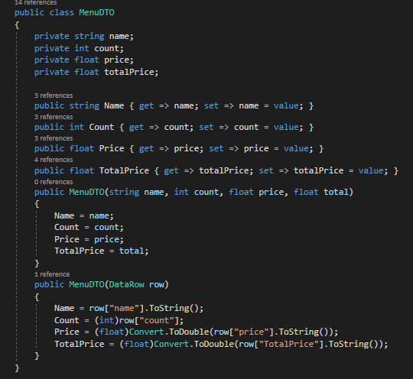

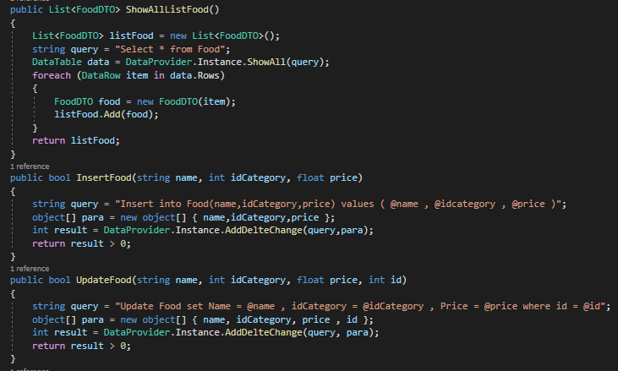

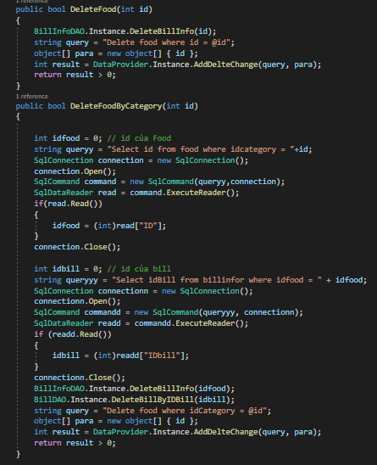

V. CONCLUSION

Food Store management system is the system for manage the business. Food Store management can vary across multiple management styles, however, there is always e common denominator when it comes to setting goals: maximizing a food store’s profitability. In order to maximize a food store’s profitability, one has to always examine and understand a food store’s operational costs and how these relate to a food store’s productivity and efficiency in delivering quality service to its customers. Management takes a very important role in controlling and manipulating the balance of costs and profitability. An effective manager must always concern himself/herself with food store issues that pertain to inventory/stocking, pricing, order-taking, and much more. Oftentimes, a food store’s profitability either rises or falls depending on how well it is being managed. Managing a food store using a well-developed software minimizes the liabilities of mismanagement and productivity loopholes. The incorporation of a Food store Management Software in the managing of various business processes entails that your food store is competitive, innovative, well-managed, and up-to-date with the latest management and business trends.

---------END-----------